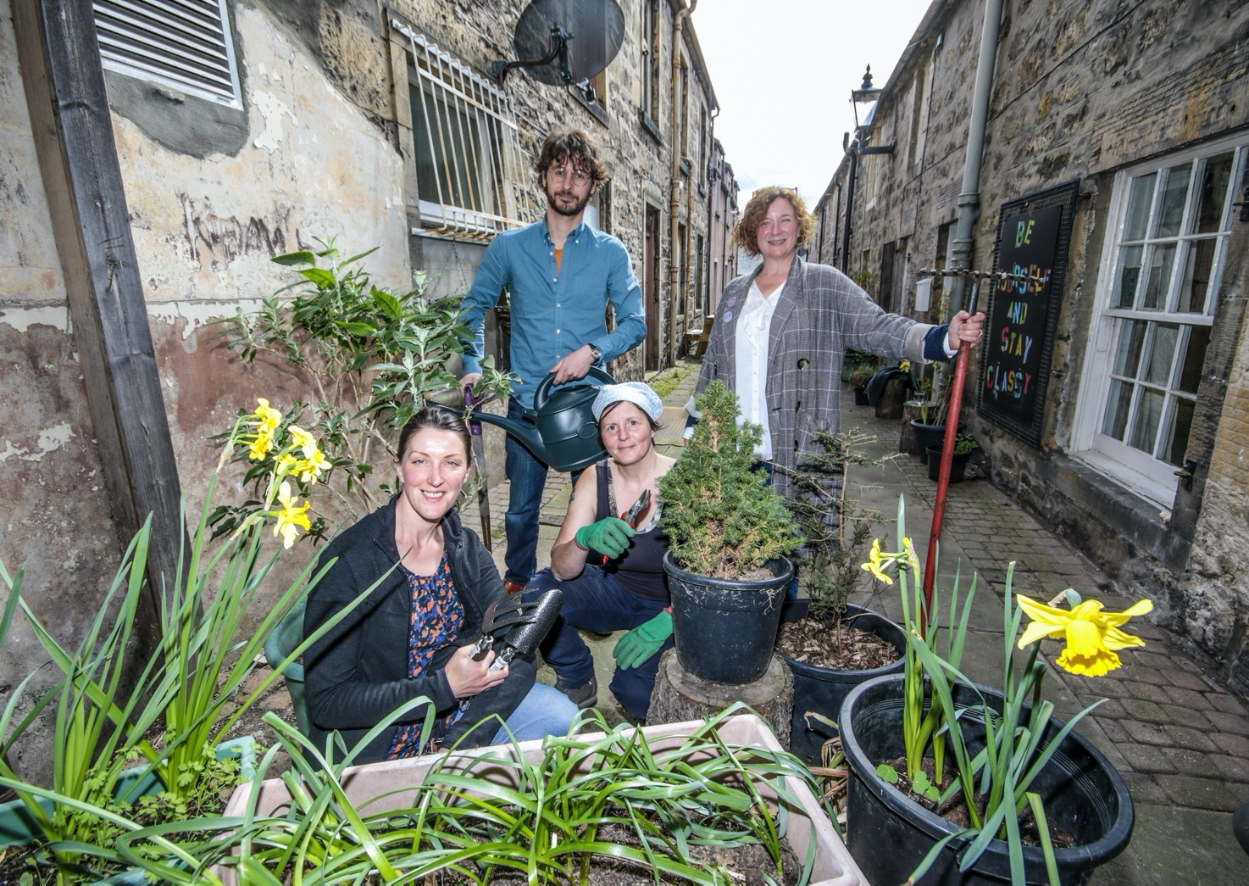

LIVING LANES | STRAWBERRY SUNDAYS | POP UP POTS | CULTIVATING CONNECTIONS | HARVEST CELEBRATION

The Unexpected Gardens programme invited local people to share ideas, make connections and inspire new ways of thinking about growing, whilst cultivating local roots and fresh connections among residents, growers, artists and community groups.

With an emphasis on edible growing, the programme featured a spring and summer long programme of community engagement activities and events developed in collaboration with community partners, growers, artists and designers, culminating in a town centre display and harvest celebration.

The project was delivered as part of Dandelion, the Scotland-wide creative growing initiative.
Dandelion was the ambitious creative programme running from April to September 2022 that demonstrated the power of collective action in a major “grow-your-own" initiative. Dandelion invited everyone to sow, grow and share – not just food, but music, scientific knowledge and ideas.

Commissioned by EventScotland and funded via the Scottish Government, Dandelion was Scotland’s contribution to UNBOXED: Creativity in the UK.

Forres’ Unexpected Gardens programme highlights included:

- recruitment of participants living in lanes and closes off Forres High Street, to be involved in a spring- and summer-long programme of growing events, advice sharing and giveaways (Living Lanes).

- five bi-weekly family crafting sessions open to the public taking place in different strategic growing locations in Forres (Strawberry Sundays).

- seven bi-weekly pop-up events on Forres High Street, offering free plants, seeds and advice (Pop up Pots!).

- monthly networking sessions with local growing partners, chaired by Findhorn Bay Arts (Cultivating Connections).

- a Harvest Celebration day of diverse events celebrating growing and community networks in Forres

- recruitment of two Emerging Creative Practitioners on job share basis to deliver programme and develop new skills

- Musicians in Residence Dopey Monkey, who responded to and created new work linked to the Unexpected Garden spaces. Musicians Danielle Price and Martin Lee Thomson originally hail from Moray.

- Interviews with Living Lanes participants developed by poet and storyteller Margot Henderson into a spoken word tour around Forres.

- Portrait photography exhibition by local photographer Alexander Williamson

Executive Summary

Staged between April and November 2022, Unexpected Gardens delivered:

- A programme of cultural events and activities focused on growing.

- A high-quality programme which promoted growing, celebrated the existing growing happening in Forres and supported art, culture and people who deliver art in the local area.

- Active participation from members of the public and local community groups.

- Development of local partnerships and collaborative working with growing partners, but also local businesses and individuals.

Unexpected Gardens achieved:

- Audience and volunteer attendance totalling just over 1,000 people across our five-month programme.

- Active community participation of 250 local people involved through the growing partners.

- 59 freelance creative professionals provided with opportunities for work.

- 8 local growing groups, makers and producers promoted and supported through commissions, networking and space hire.

Unexpected Gardens Programme

Living Lanes

Recruitment of participants living in lanes and closes off Forres High Street, to be involved in a spring- and summer-long programme of growing events, advice sharing and giveaways.

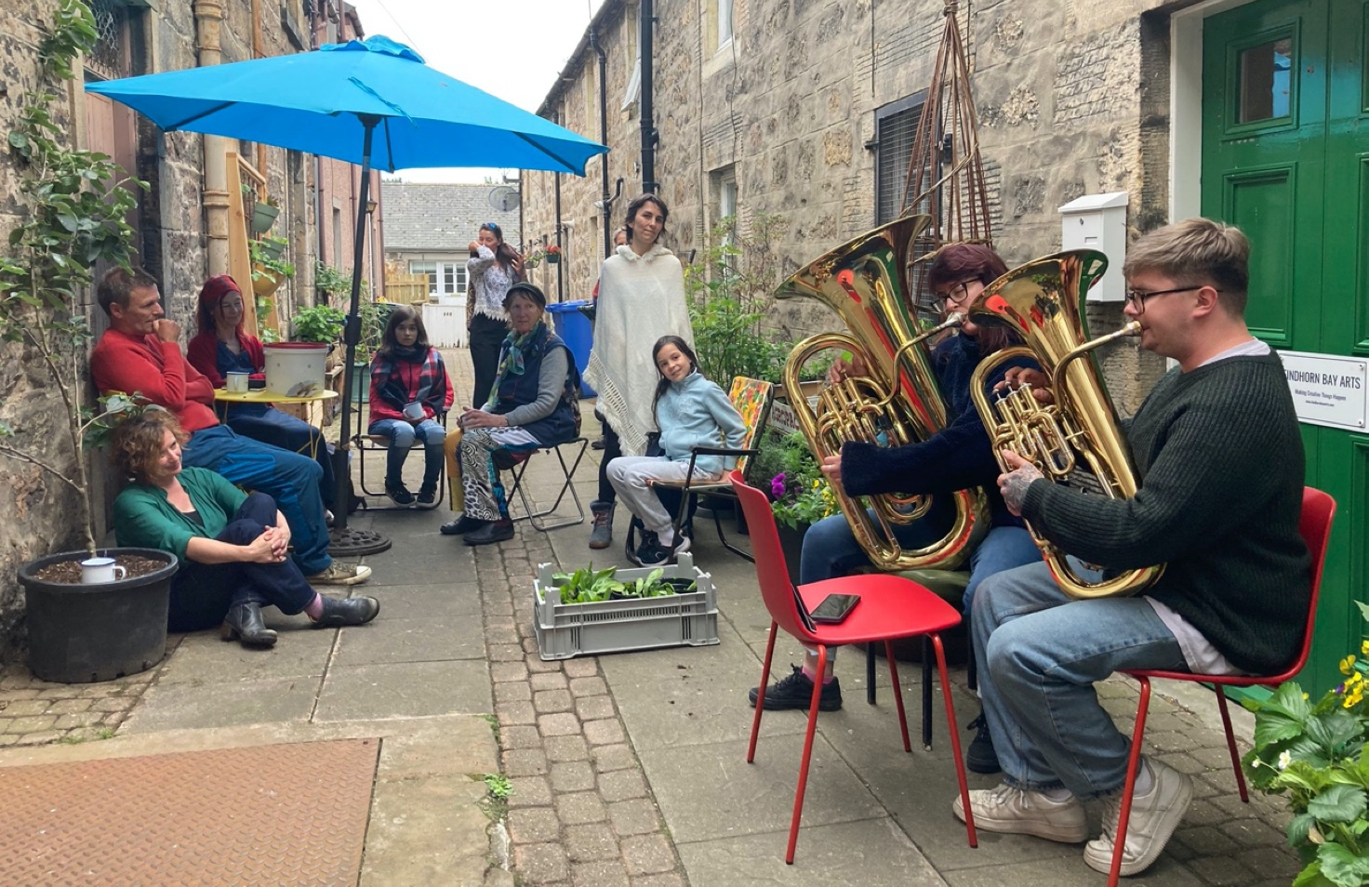
Musicians in Residence Dopey Monkey performing in the lane outside FBA’s offices.

Overview

From April - late August, a total of 24 households were recruited, by the Emerging Creative Producers (ECPs) going door to door and establishing relationships, to be ‘Living Lanes Participants.’

These participants would sign up to receive advice about growing, planters, seeds, plants and other garden units, and also be invited to meet-ups where food, music, poetry and knowledge about growing was shared.

The four meet-up ‘ceilidhs’ took place at the end of each month, using Orchard Road Studios (a local artists’ space part of which was hired for the project nursery), with the exception of the June meet which took place in the lane where the FBA office is located.

Aims

The aim of this strand was to engage with town-centre residents who live on the pedestrian lanes of Forres. These properties typically have very little outside space, and the lanes themselves are typically narrow, suffering from a lack of light and rain. Whilst almost all lanes are public rights of way, many people in Forres do not actively use these lanes to get through town.

The aim was to help residents of these lanes engage with growing where they may not have ever engaged with growing before, and to bring greenery and life into these lanes for public beauty. It was important to meet the residents where they were with their growing journey, supporting those who were already growing, as well as introducing total novices to growing.

KPIs (Key Performance Indicators)

- A safe and positive experience for every single targeted participant, whether recruited or not,
- At least five households across four lanes recruited onto the programme,
- Every participant to have the offer of something physical and tangible to improve their lane or their growing journey, with 30% of the participants being offered bespoke solutions for their individual spaces in the lanes.

Top line numbers

Recruitment was: 24 households signed up out of 40 households targeted (60%) which was seen as a sign of strength for the project idea, and that residents had confidence in the project aims.

People from 15 of these households attended at least one Living Lanes meet-up (63%), and 17 people from these households took part in a specially curated Living Lanes Walking Tour at the Harvest Celebration (out of a total of 20 tickets sold - 85%)

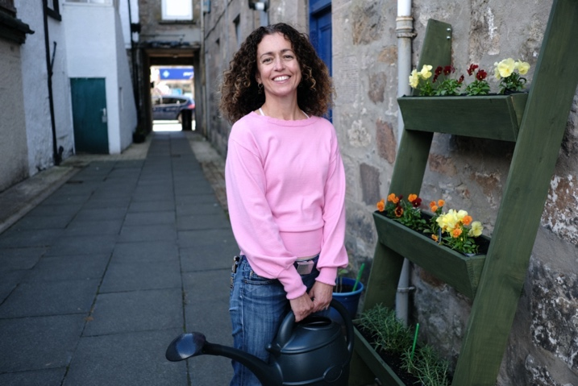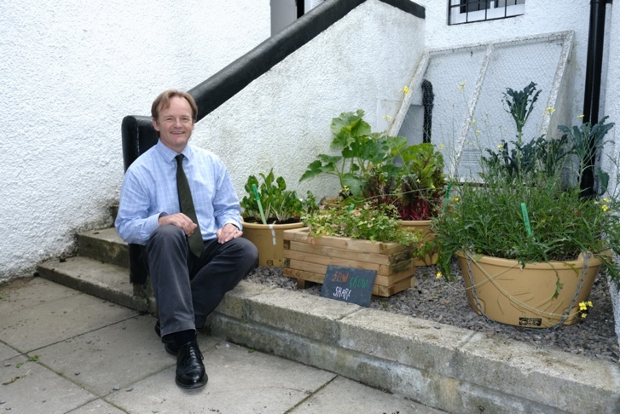
Living Lanes participants

Reflection on planning and execution, and quality of output

A walk of Forres was undertaken by the ECPs and Hub Lead, and the lanes off the High Street were looked at, thinking about suitability for the project. First thoughts and questions included:

- is there safe public access to this lane?
- what sort of growing seems to be taking place here already?
- do we already know someone who lives here?
- is this lane mainly residential or businesses?

After the initial whole-town walk, an upper- and lower limit for the High Street was set, as our brief required us to focus on town centre. A letter was then created, inviting participants to sign up and receive information, advice, seeds and planters over the summer months and the ECPs spent time knocking on doors, trying to connect with residents face-to-face as much as possible.

Due to the nature of each household having quite specific growing requirements, the focus was on the ECPs building a strong and ongoing relationship with the participants. It was clear in the planning stage that some residents may have specific access requirements, and all considerations were made to ensure the project was accessible as possible.

Some of the plants and seeds given out were, with the reasons for the choices:

Runner Beans in Whisky Barrel Planters | Planters made from recycled whisky barrels were chosen due to Forres’ Moray Speyside location, home to a number of distilleries. Runner beans are relatively simple for new growers and provide attractive displays throughout the spring and the summer.
Vertical Garden Units with lettuce, rocket, chives, spinach | Vertical units made from recycled pallets by local artists to minimise carbon impact, and the plants chosen as easy to grow and instantly useful in salads, sandwiches and ‘on the go’. These plants also do not require much direct sunlight and so are well suited to the lanes.
Tattie / courgette sack | Sack made by a local seamstress using recycled compost bags (repurposing of plastic) and coffee bean sacks from a local roastery. Potatoes as they are easy to grow and are local to this part of the world. Courgettes could be moved into these sacks in the later summer, after the potatoes had been harvested.
‘Yellow planter’ with sunflowers | Repurposed plastic round planter which was surplus from Forres in Bloom, filled with sunflowers, providing attractive displays and particularly interesting for participants with children.
Mushroom buckets | A local company provided ‘grow your own mushrooms’ using recycled animal feed buckets. Mushrooms were chosen to be a part of this project due to the fact that a lot of the lanes are darker than a wide street or garden, and can also be damp; good conditions for growing mushrooms.
Microgreen kits | A local company was engaged to provide microgreen growing kits and support to participants. The kits were chosen as they require very little space to grow tasty and fresh food, ideal for participants where space is at a premium.

As well as the physical units and plants, Eva, along with other gardeners on this project undertook around 24 walks around of the lanes (approx 1.2 per week) to ensure that the plants were distributed with an overall balance, and to keep an open dialogue with participants about their specific needs for growing.

Evaluation against KPIs and impact

A safe and positive experience for every single targeted participant, whether recruited or not.

MET, with points to note including ongoing sensitivity to how much support each participant needed, and to keep the project accessible to all. Every one of our recruited participants interacted positively with the project, and we had a lot of positive feedback verbally and on feedback forms.

At least five households across four lanes recruited onto the programme.

EXCEEDED: there were 24 households across 14 lanes recruited onto the programme.

Every participant to have the offer of something physical and tangible offered to them to improve their lane or their growing journey, with 30% of the participants being offered bespoke solutions for their individual spaces in the lanes.

EXCEEDED: almost all participants can be said to have been offered bespoke solutions, as the dialogue between participants was an ongoing process.

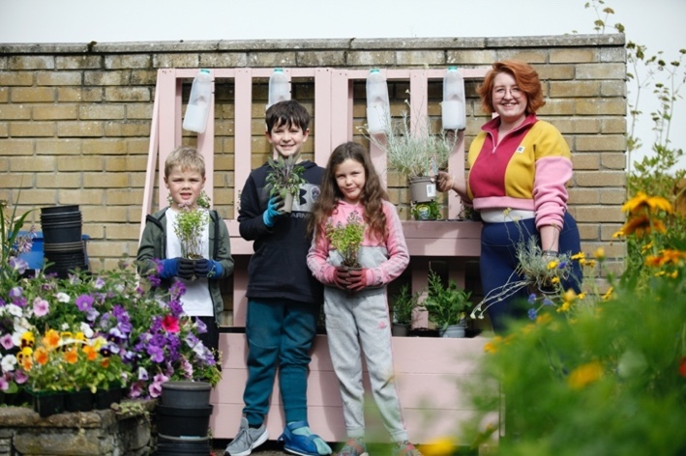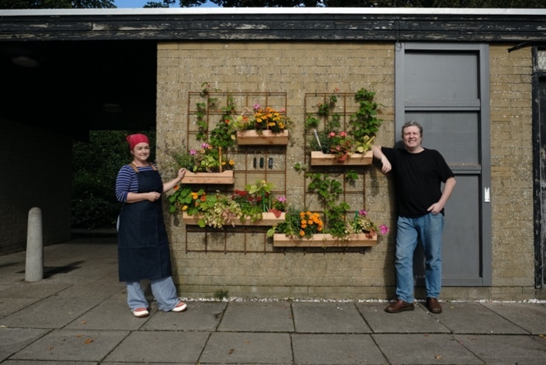
Vertical gardens in Forres

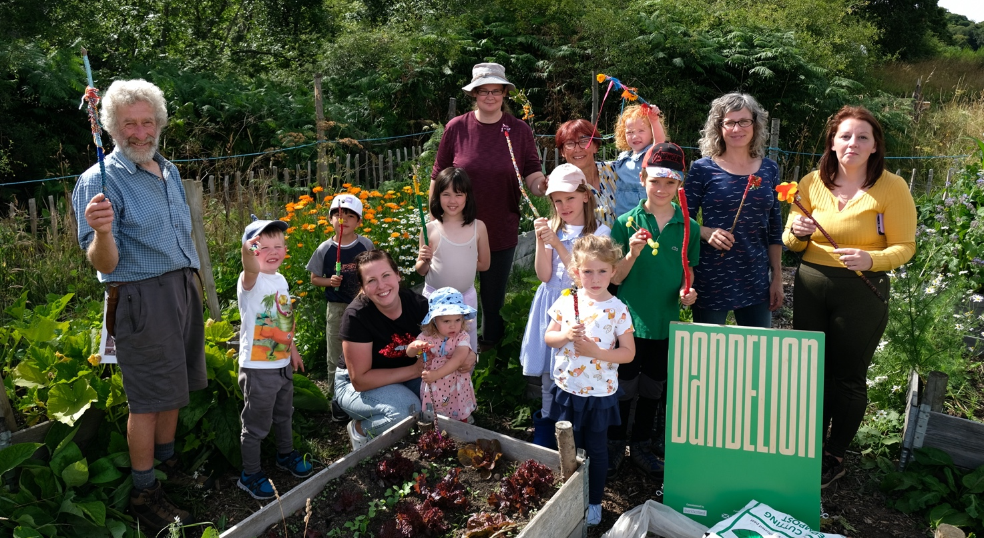
Strawberry Sundays workshop hosted by Forres Friends of Woods and Fields

Strawberry Sundays

Five bi-weekly family crafting sessions open to the public (bookable but free) to take place in different strategic growing locations in Forres.

Overview

Two local craft artists, both of whom had previous experience working with children and young people, were engaged to deliver a programme of five 1hr long crafting projects.

Aims

The aim was to have no upper or lower age limit, and to be accessible to all. The crafts chosen were: Flower Crowns, Hapa-Zome (Japanese cotton printing using leaves and flowers), Flower Wands, Suncatchers and Bug Hotels.

These were chosen as they were relevant to the theme of ‘growing’ and would encourage a new range of people to sign up and learn more about the broader aims of the Dandelion project.

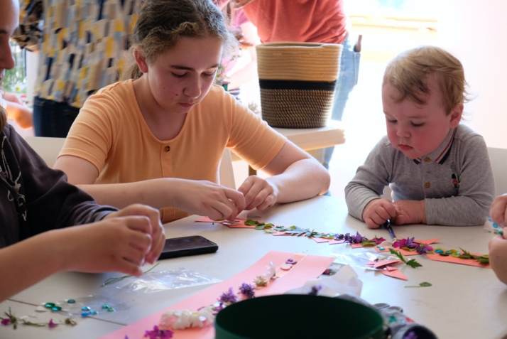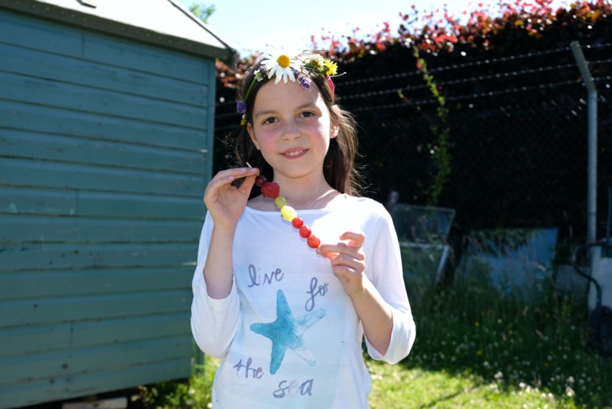
Strawberry Sundays workshop hosted by Transition Town Forres

It was decided that the locations for these activities would rotate each time to be in a different local ‘growing partner’ location, thus enabling the growing partners to benefit from increased public awareness, and the participants to benefit from discovering a new growing area of Forres about which they previously might not have been aware.

KPIs

- a safe and positive session for every single participant.
- every single participant has something physical, tangible and related to the final product to take home with them at the end.
- every participant, for whom it was not the first visit to that location, to learn something new about that location.

Top line numbers

Capacity for each event was 20 people, and the average number of people who attended was 15 each time. All events sold out within two weeks of being advertised online. There were no-shows and cancellations for each event, with the cancelled tickets being allocated to those on the waiting list. The no-shows may have reflected the fact that the events were free.

Reflection on planning and execution, and quality of output

It was felt that the balance of activities was diverse enough for different people to sign up to each one, yet all being linked by a common theme.

Each different location presented different challenges, and so a site visit by the ECP and the artists before agreeing and advertising was carried out, and in one case, a portable toilet was agreed to be installed as a prerequisite for hosting the Strawberry Sundays session there.

The sessions were professionally delivered and all participants were able to produce things they could take home.

The ECP was responsible for providing juice and strawberries, but also engaging with the participants to get them talking about what they were doing. Several participants commented on how great the ‘teachers’ were and there was a positive atmosphere all around.

The work produced was of high quality, and all beautiful as well as functional. There were several children at each event and they too were able to make beautiful products.

Evaluation against KPIs and impact

A safe and positive session for every single participant:

MET, as gleaned from positive feedback from the sessions.

Every single participant has something physical, tangible and related to the final product to take home with him at the end:

MET, with things to note including comments from one participant: ‘I now have the skills to do this again at home!’ and that a lady with a toddler was able to be supported so that the toddler was meaningfully engaged too.

Every participant, for whom it was not the first visit to that location, to learn something new about that location:

MET, with things to note including one location providing a full presentation with a hand-drawn map and offering a tour around the site to the participants.

Participants felt ‘upskilled’ in each activity, and all of the activities was something that could have then been recreated at home with minimal cost.

Participants also commented positively on the two events which took place outside, as it was joyful to be working with others outdoors. The children were able to participate fully and independently, and so felt a real sense of pride in what they created at the end.

Pop Up Pots outside the FBA Shop with the Mad Hatters of Moray
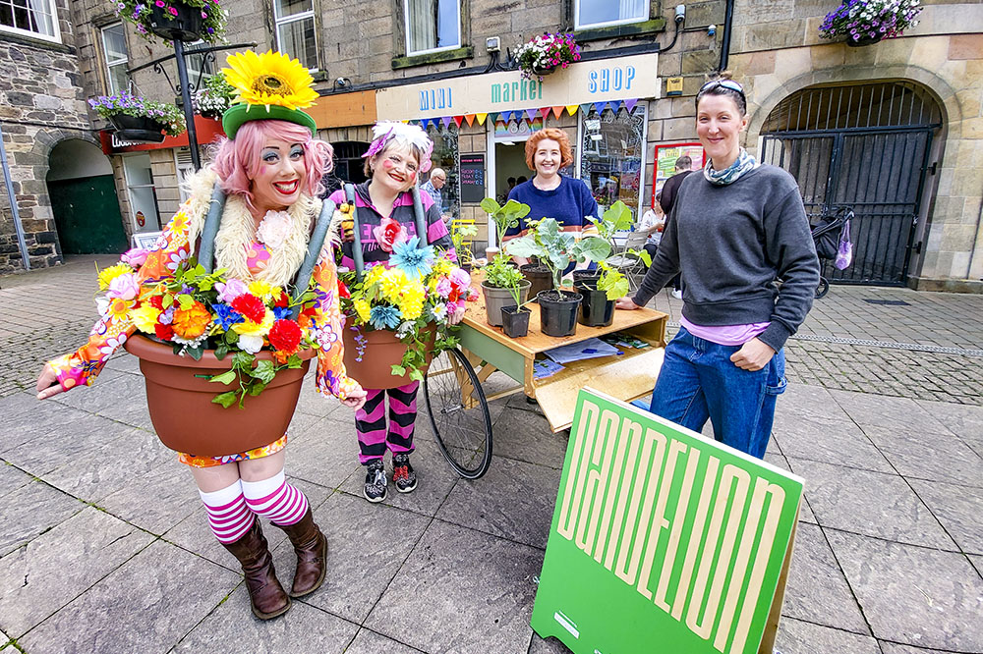

Pop-up Pots!

Seven bi-weekly pop-up events on Forres High Street, offering free plants, seeds and advice.

Overview

In the spring and summer months, every other Saturday morning from 10:00 - 13:00, a specially commissioned planting barrow was wheeled out to the High Street, along with a Dandelion sign and other FBA branding, and members of the public were encouraged to come and pot up plants and ask questions about growing. Seeds and plants included lettuce, chives, rocket, strawberries and beans.

Eva (ECP) was chosen to deliver these activities as the expert in horticulture, and a local theatrical arts group: ‘The Mad Hatters of Moray’ were engaged to be present as a visual enticement to draw in the public.

Aims

The aim of this strand was to provide a quick and accessible growing activity for anyone, without the need to sign up in advance. Pop up Pots also ensured that the rest of the programme was able to be advertised to interested people, and thirdly that a space was created for any questions about growing to be put to an expert at no cost.

KPIs

- A positive and safe experience for all participants
- At least 12 engagements per session (one per 15mins) with public
- Every session to have told at least one person something new about the Dandelion project, or introduced the Dandelion project to someone new

Top Line Numbers

A total of 164 people engaged with pop-up-pots over seven events (AV 23 per event). Postcodes were collected, which showed that the vast majority of people were local to IV36 (Forres and area), but also included visitors from Elgin, Inverness and even Argyll.

Reflection on planning and execution, and quality of output

The planning stages of these events quickly highlighted the need for a gardening expert to be on hand for the events, and that an element of art or theatre would also be useful to draw people in. The Mad Hatters of Moray (a local theatre group) were drafted into every other session, with a Margot Henderson, a local storyteller, being engaged for the others.

The event turned out to be fast-paced and a ‘really inspiring fun’ (quote from the ECP delivering it). There were a ‘wide variety of people from different walks of life’ who wanted to engage, and mostly different people each time.

The expertise on hand meant that all participants got a high-quality experience of planting, and ‘felt able to ask questions’ from the ECP delivering the activities.

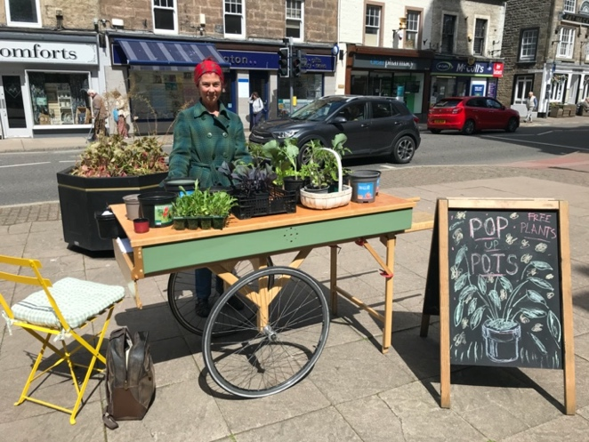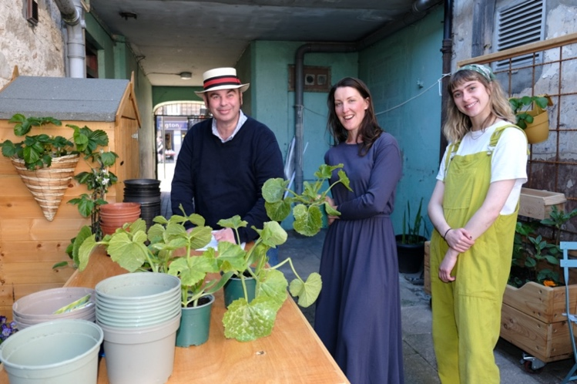
Pop Up Pots with storyteller Margot Henderson

Evaluation against KPIs and impact

A positive and safe experience for all participants:

MET, with some really positive stories about growing captured.

At least 12 engagements per session (1 per 15mins) with public.

EXCEEDED: with an average of 23 engagements per session, this is almost double what was originally hoped for and shows that the public were very happy to engage with what was provided.

Every session to have told at least one person something new about the Dandelion project, or introduced the Dandelion project to someone new.

MET: the first few sessions especially were seen as a great marketing platform for the Dandelion project overall, and there were also 4 new living lanes participants recruited as a direct consequence of meeting at Pop-up-Pots.

Cultivating Connections

Monthly networking sessions with local growing partners, chaired by Findhorn Bay Arts, culminating in an afternoon of discussions and talks about local food networks.

Overview

Forres has a very active growing community with several different growing projects that are well-established, as well as a few newer ones. From the outset of this project, it was felt that a bottom-up, socially engaged practice would be the best fit delivering the Dandelion project in this location, i.e. FBA would liaise with the groups and offer them ‘growing partner’ status on this project.

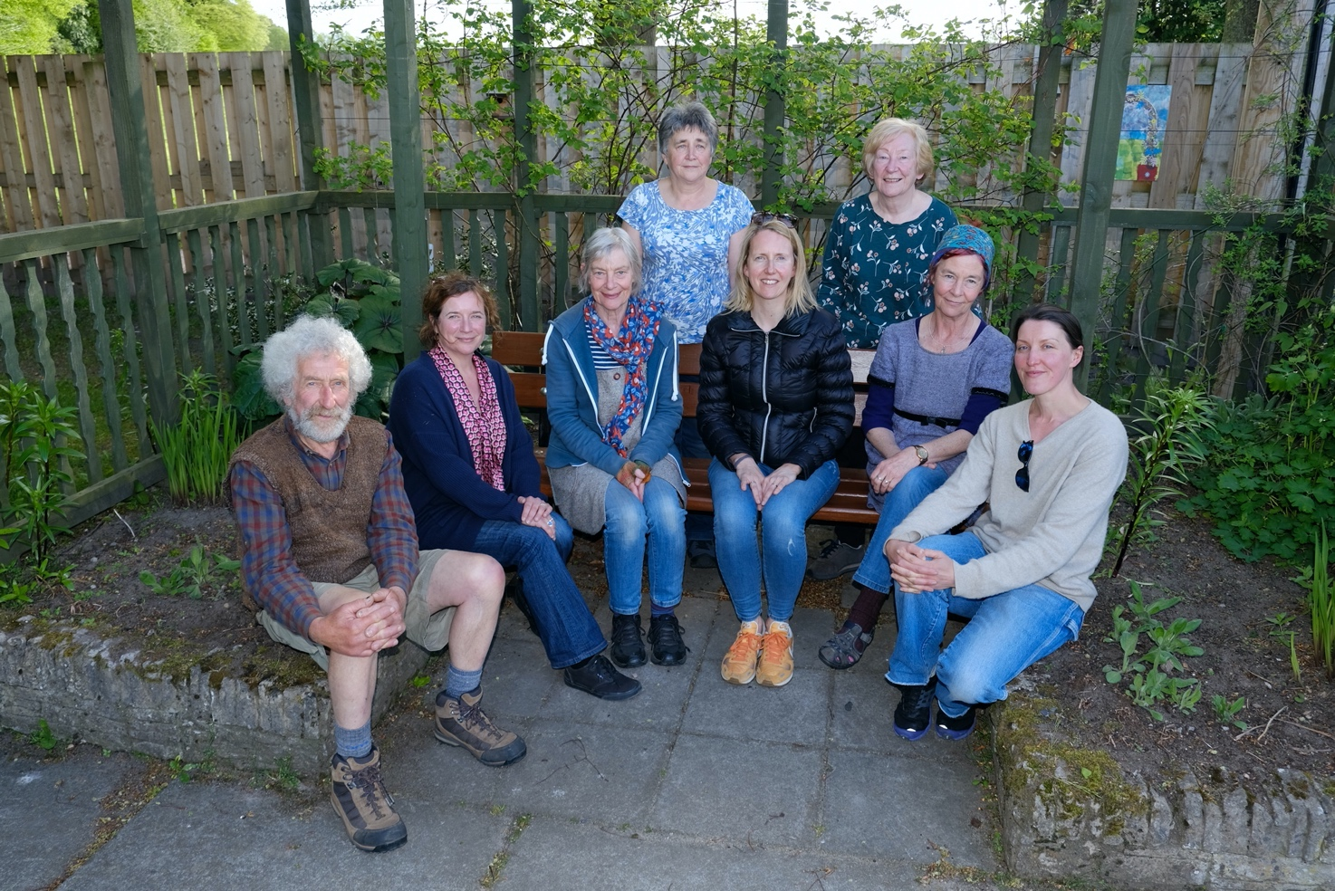
Members of the Cultivating Connections network

The groups were:

- Transition Town Forres (Community Allotments and Social Enterprise) https://ttforres.scot/

- Incredible Edibles (growing edible produce in the town centre) https://www.incredibleedible.org.uk/

- Forres Orchard (community orchard trees of apples, near the Mosset Burn in Forres)

- Forres Friends of Woods and Fields (a large area of land, recently turned over to the community growing vegetables and providing education for young people) https://www.forresfriends.com/

- Forres in Bloom (A long-established and highly regarded organisation dealing with flower displays in Forres and education) https://www.forresinbloom.org.uk/

- Biomatrix Fresh Water Solutions (an innovative company specialising in growing solutions for lakes and rivers) https://www.biomatrixwater.com/

The Growing Partners were offered £300 each to support ‘the growing or building of something new which would add value to the organisation’, as well as invited onto the Cutivating Connections Forum in the form of monthly meetings, chaired by FBA, which had not previously existed.

On Saturday 10th September, an afternoon of talks was curated, bringing together these growing groups and members of the public. This event was a three-hour long afternoon event with four speakers and audience discussions centred around the question: “What do we want our local food networks to look like by 2030?”

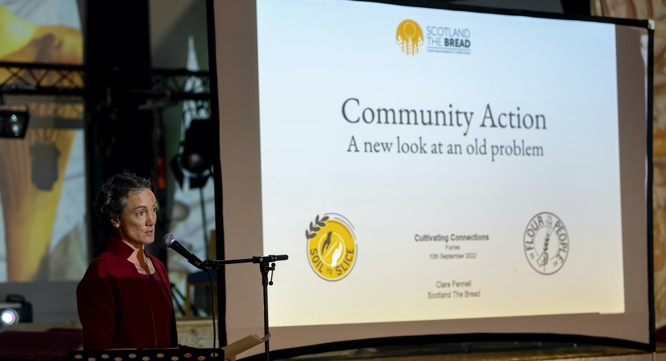
Clare Fennell of Scotland The Bread speaking at the Cultivating Connections event

The speakers were from:

- BioMatrix Freshwater Solutions, a local company creating innovative growing solutions including floating growing structures.

- Scotland the Bread, a collaborative project to grow better grain and bake better bread with the common purposes of nourishment, sustainability and food sovereignty.

- Aurora Group, a local company which designs circular economy and bio-economy approaches for environment restoration, food security improvement and reintroducing nutrients into the production loops.

- Moray Food Plus, a local charity which provides a variety of services to those either experiencing or at risk of food insecurity.

Attendees were encouraged to participate actively in break-out sessions, noting their thoughts onto large pieces of paper which were displayed around the room.

As part of this event, The Town is the Menu was also delivered, in the form of a four-course menu, inspired by Forres, provided for free to all attendees.

Aims

The aim of this strand was to strengthen the network of growers in Forres, and to create a platform for shared learning, project signposting and mutual help. It was also envisaged that a public-facing event, hosted by these groups, would be an ideal way to engage locals to talk about important food issues in the area, giving Forres residents ownership of the conversation about their food scene, landscape and security.

KPIs

- Over 50% of the growing groups in Forres signed up to be growing partners.
- All growing partners signed up to make use of £300 to support the growing or building of something new which would add value to their organisation.
- Constructive meetings with a quorum of groups represented, discussing and developing new, integrated ideas about growing in Forres.

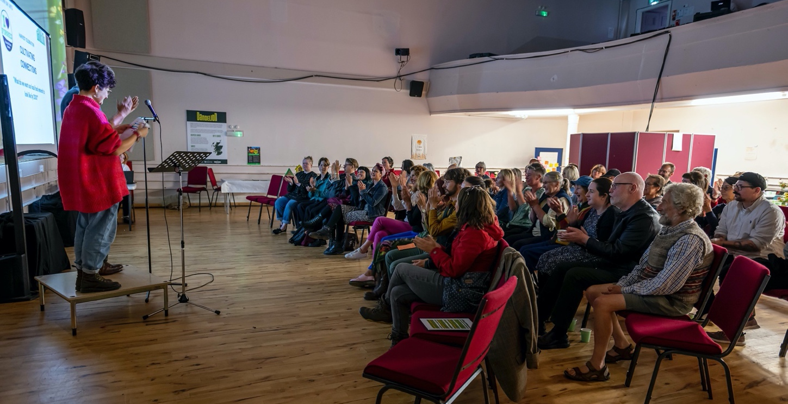
Cultivating Connections attendees

Top Line Numbers

There were 6 Growing Partners (GPs) signed up, and they remained GPs for the duration of the project. At the end of the project, one additional growing organisation was highlighted in Forres, and that organisation, while not officially at GP status, was also brought into the team and supported to appear at the Harvest Celebration alongside the other GPs. The total number of volunteers for all of the GPs is roughly 100, and they all benefited from the information generated from the monthly meet-ups, as well as benefiting from the new projects financed by the £300 offered to each group.

40 tickets were initially offered for the September 10th event, which sold out quickly. After some extra budget, an extra 20 tickets were offered, which also sold out. There was a total attendance of 54, with some cancellations due to the death of the Queen which happened that week.

The projects delivered by the funding included:

- Naturally Useful - Composting toilet for the educational facilities.
- Incredible Edible - More raised planters for community growing.
- Forres Friends Of Woods And Fields - Open Day event.
- Forres Orchard - Tool shed for the Community Garden at Sanquhar Woods.
- Transition Town Forres - Seed bomb making workshop and facilitation.

Reflection on planning and execution, and quality of output

Delivering a brand-new community garden project in Forres was always going to have to be a bottom-up, socially engaged approach, and so it was beneficial that the links to most of these growing organisations were already established before the Unexpected Gardens project was conceived.

From the outset, all of the GPs responded positively and openly to FBA’s ideas of creating a network and offering support this season. Each monthly meeting was well-attended with always at least one representative from over 50% of the groups present. The organisations, in this way, were given a voice to contribute to the creative direction of the Unexpected Garden project right from the outset, and so felt a sense of ownership when the project started to be delivered in the summer months. Through these meetings, the

ECPs got to know the key players in each organisation and in the Forres growing world, which meant that it was a lot easier to deliver the project, knowing ‘you had a lot of people in Forres pulling in the same direction’ [ECP quote] to rely on.

The September 10th event was planned in collaboration with TTF, and from the outset, high-quality speakers with experience of such events were sought out. They all delivered relevant and interesting talks which inspired attendees in their conversations about the main question: ‘What do we want our local food networks to look like in 2030?’

Evaluation against KPIs and impact

Over 50% of the growing groups in Forres signed up to be growing partners.

MET. All of the growing groups who were invited to become GPs took up the offer, making a really strong network involving around 100 people overall supporting the wider Dandelion aims.

All growing partners signed up to make use of £300 to support the growing or building of something new which would add value to their organisation.

PARTIALLY MET - with one exception, the GPs all accepted the offer of £300.

Constructive monthly meetings with a quorum of groups represented, discussing and developing new, integrated ideas about growing in Forres.

MET.

Harvest Celebration - The End of the Project

To celebrate the end of the project, the FBA Mini Market Shop expanded with extra producers and activities taking place on the High Street, local artist Margot Henderson gave a specially curated Walking Tour around the lanes of Forres, and an evening ceilidh took place in Forres Town Hall, open to the public. The Cultivation Connections Talks event also took place on this day.

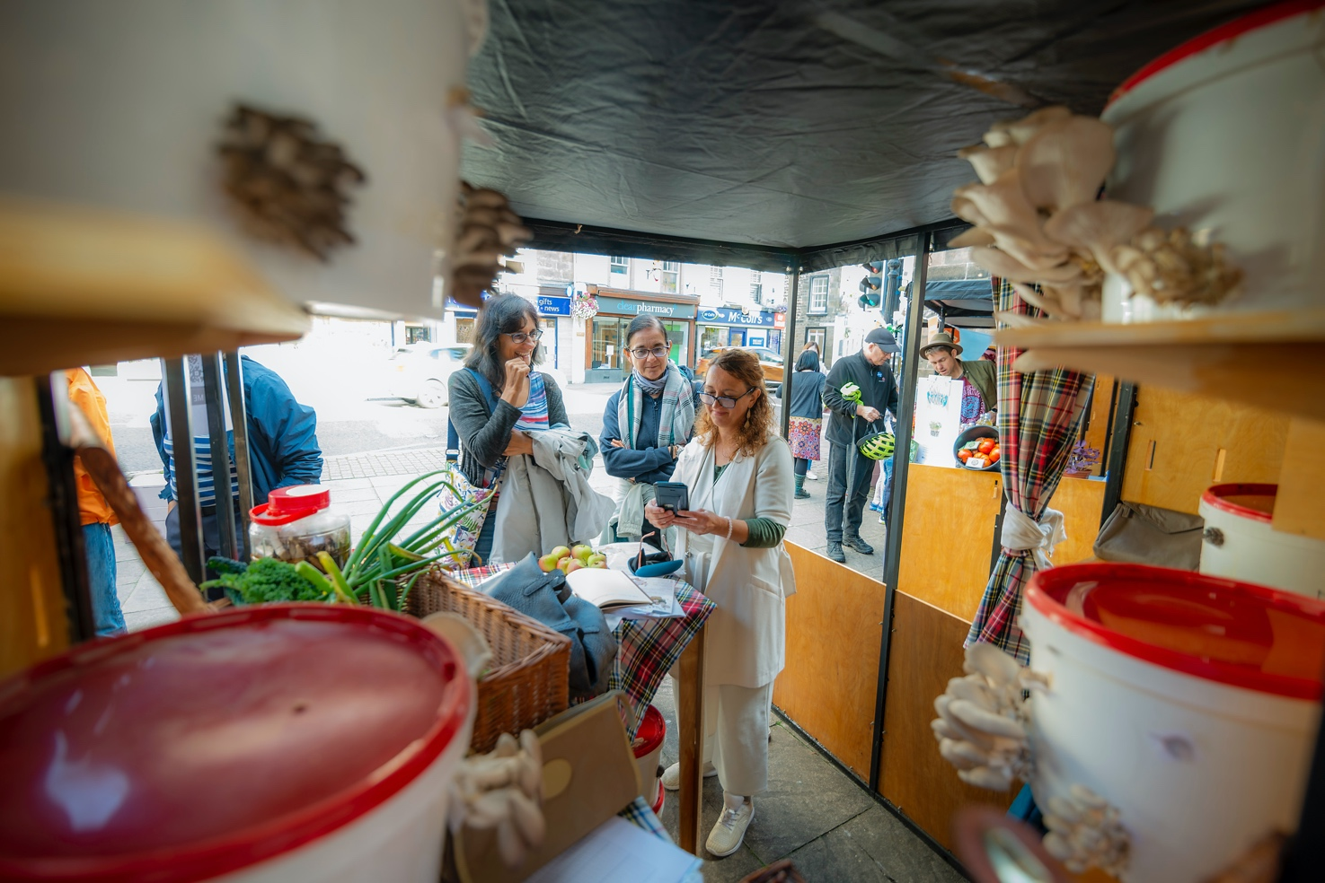
Green Grow Mushrooms at the Harvest Celebration market

On the market morning, additional stalls were manned by:

- Dopey Monkey, a brass duo, Musicians in Residence for the project who engaged the public with a circuit-board piano made from vegetables. They were promoting their album of music, specially composed in and about Forres, celebrating the project by using spoken word, field recordings and original compositions. The album takes place as a sound walk around Forres through the app ‘echoes’.

- Artists Marion Normand and Oonagh Brady, providing a cotton bag decorating activity using plant stencils, and wooden tile decorations to go inside them

- Local grower Ute Wegener providing extra organic vegetables to sell

- Local producers Daniel Oliviera and Iain Findlay talking about microgreens and mushrooms respectively

- Visiting Artists Emma Wheetman and Rachel Laycock provided a seeded paper-making workshop as partners from the Festival of Thrift in Redcar, England.

The Cultivating Connections event, detailed above, was a three-hour long afternoon event with four speakers and audience discussions centred around the question: “What do we want our local food networks to look like by 2030?”

Participants were encouraged to note their ideas down, and the word cloud below shows some of the key words that came up in conversations.

A selection of the most common words included:

- Food
- Community
- Local
- Network
- Growing

This showed that, when thinking about food neworks, the majority of participants were looking at grown vegetables and fruit, and what was needed was increased awareness of local networks to grow and deliver this fresh produce.

The word ‘community’ was also highly mentioned, and comments in full talked about the importance of continuing community meals and providing means to engage the whole community, including children and young people, to learn about, taste and grow fresh produce locally. A full text of the submitted comments can be found in the appendix of this report.

The Living Lanes Walking Tour celebrated the residents who had engaged with the project, explored the history of the lanes and also gave a chance for Margot to deliver ‘green leaf plaques’ at certain locations, marking special places on the journey of this project.

For the evening event, a local band The Boatshed Band and DJ Dolphin Boy was hired to provide the music, and catering was provided by Brett Mather. The light design included the mapping of the inside of Forres Town Hall by visual artist John McGeough.

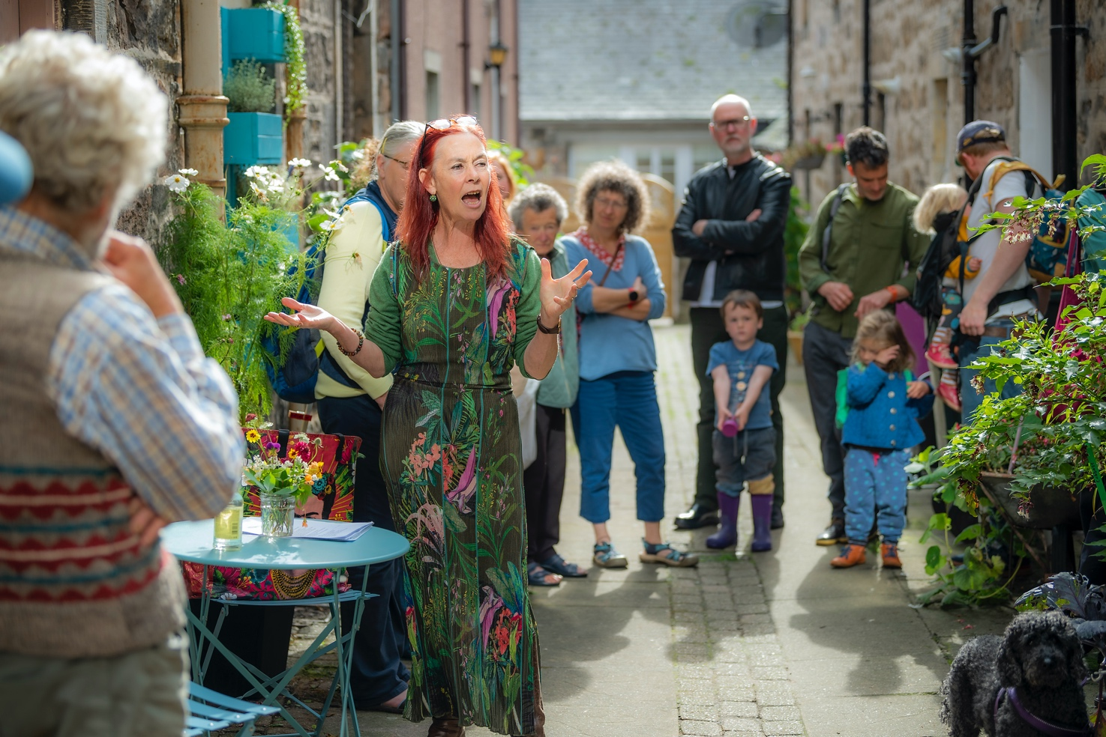
Poet and storyteller Margot Henderson leading the Living Lanes tour

Audience Numbers on 10th September:

FBA Shop: 248 sales (48% increase on a usual Saturday morning)
Marion and Oonagh: 75 participants
Paper Making: 50 participants
Dopey Monkey: 60 people engaged
Walking Tour 20 participants
Ceilidh: 150 audience
Cultivating Connections 54 audience participants

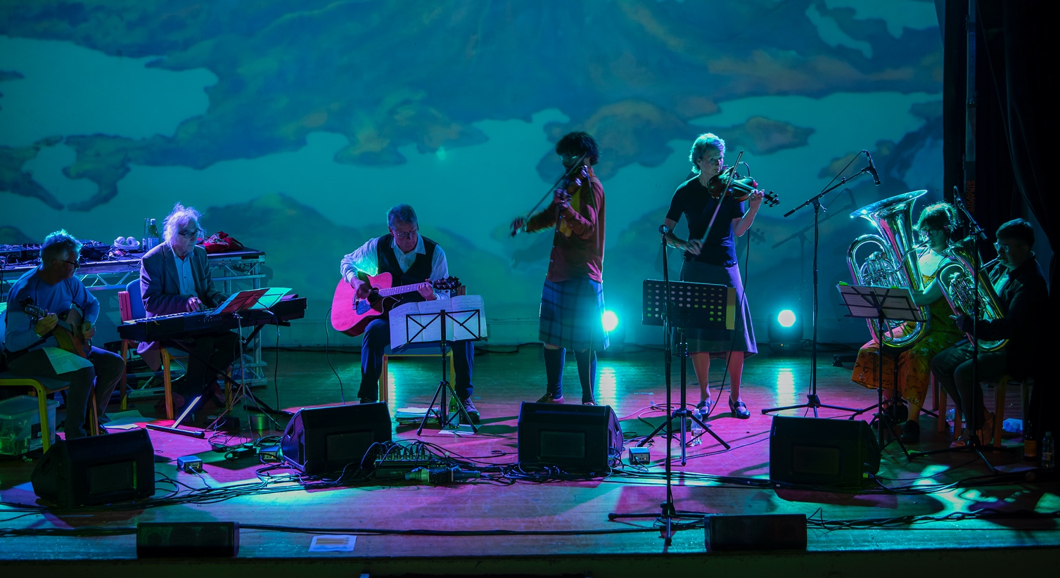
Dopey Monkey and The Boatshed Band performing at the Unexpected Ceilidh

Development Aims and Legacy

The Unexpected Garden project was conceived by Dandelion to take place over one growing season in 2022, ending in September with the Harvest Celebration.

Our Unexpected Garden in Forres gave FBA a real insight into growing in Forres, and, at the end of the project, the following continuation and development ideas presented themselves for consideration, either mentioned in feedback forms or posed as future potential FBA projects.

- As the network of Forres growers had been strengthened through the Unexpected Gardens project with monthly meetings under the banner of ‘Cultivating Connections’, the continuation of these meetings would continue to support and strengthen local networks and future partnership projects.

- The feedback from the Cultivating Connections event demonstrated an engaged core of people passionate about working towards more sustainable food networks, and so a future event, including the creation of a Manifesto for Forres, would enable a formal collection of residents’ views and turned into a visual work of art, which

then could be presented to local and national government.

Such a future event would also be appropriate for finding or developing a smaller team of people who would take on the task of delivering on the manifesto and working at the practical details of realising change and development in how local communities grow, procure and use food.

- The Living Lanes participants, some of whom were supported to grow for the first time, would be interested in and benefit from a continuation of the project in some form for the next season, enabling them to continue learning and growing in their lanes, developing neighbourhood connections and contributing to positive health and wellbeing.

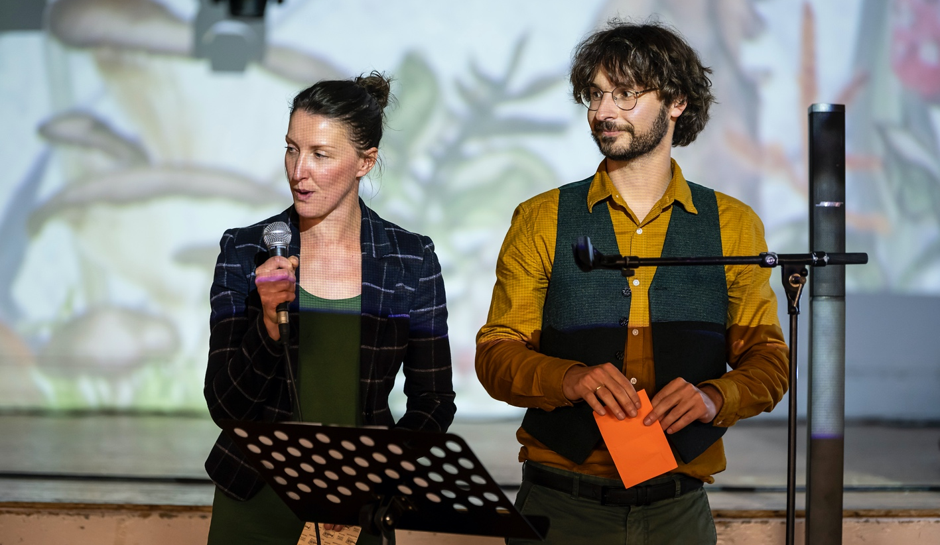
Unexpected Garden Emerging Creative Producers Eva Zandman and Adam Csenki

These development potentials are in addition to the realised legacy outcomes of the project below:

- 20 vertical garden units and 30 smaller planters were given away and continue to be displayed around Forres, outside residential houses and also in public places.

- The Sound Walk and Music Album created by Dopey Monkey is currently online and available to listen to at no cost. The soundwalk, listenable through the app ‘echoes’ enables visitors to Forres to learn more about the project and the community growing partners through music.

- 70 fruit trees to be planted in various locations in Forres, which, over 25 years will capture over 45 tonnes of carbon dioxide as a project offsetting tool.

Appendices

1. Participants Feedback

Unexpected Ceilidh
“Best ceilidh of the year!!! Great band, amazing caller, good atmosphere.”
“ceilidh - great band, great venue, great stovies.”
“We’ve needed a big party since covid times.”

Pop Up Pots
“​​I am visiting the area in my camper van and have been wanting to get something to grow on my windowsill, this is ideal! Now I will be able to harvest my own salads!”
“This is amazing! Thank you very much, my tomato plants have all died so I can now replace them with these ones.”

Living Lanes
“​​it was excellent to see how much the lanes changed for the better.”
“I love the way that gardening in the lanes spread.”
“It was a way to re-engage after covid and I enjoyed seeing people getting enthusiastic about growing food.”

Strawberry Sundays
“It was really wonderful to meet new participants.”
“We began to feel like friends and to also to discover new locations and venues.”
“Getting a time to stop in this busy life and just do something fun with other people is rare nowadays, and it is so needed!”

Cultivating Connections
“You gave contact between all the small projects in area which were flying solo beforehand.”
“The Growers Group meetings helped build connections.”
“Totally Magical.”
“More of these events! Keep the conversation going.”

2. Marketing & Communications Output

Website
Page | Visitors | Page Views
Project / Unexpected Garden | 422 | 569
What's Happening / HC Sow Grow Share | 321 | 399
What's Happening / Strawberry Sunday | 222 | 322
What's Happening / MIR Open Call | 157 | 211
News / Eva and Adam Found | 138 | 151
What's Happening / Pop Up Pots | 93 | 122
News / MiR Announcement | 92 | 108
Project / Dandelion | 68 | 78
News / UG Launch | 61 | 75
What's Happening / ECP Open Call | 48 | 52
News / UG Announced | 46 | 51
Blog / Cultivating Connections | 22 | 33
Blog / Strawberry Sunday | 4 | 5
Blog / Dopy Monkey Music | 2 | 2
Total | 1696 | 2178

Project Blogs

Every Day Should be a Strawberry Sunday! – 12 July 2022
https://findhornbayarts.com/blog/every-day-should-be-a-strawberry-sunday/

Cultivating Connections in the Unexpected Garden – 29 August 2022
https://findhornbayarts.com/blog/cultivating-connections-in-the-unexpected-gardens/

Celebrating a Summer of Sowing, Growing and Sharing – 12 September 2022
https://findhornbayarts.com/blog/sow-grow-share-an-unexpected-gardens-harvest-celebration/

A Symphony of Unexpected Growing – 09 November 2022
https://findhornbayarts.com/blog/a-symphony-of-unexpected-growing/

Social Media Reach

 | Twitter
 | Posts | Engagement | Reach
 | 40 | 582 | 13208
 | Facebook
 | Posts | Engagement | Reach
 | 29 | 6077 | 48221
 | Instagram
 | Posts | Engagement | Reach | Views (Reels)
 | 34 | 1146 | 24729 | 16473
Total | Posts | Engagement | Reach | Views (Reels)
 | 103 | 7805 | 86158 | 16473

Media Coverage

Grow your own food project reveals plans for edible gardens and vertical farms
The Scotsman - 14 February 2022
https://www.scotsman.com/whats-on/arts-and-entertainment/grow-your-own-food-project-reveals-plans-for-edible-gardens-and-vertical-farms-3567633

Lanes and alleyways of Forres to see unexpected growth from cultured gardens
Forres Local - 14 February 2022
https://forreslocal.com/lanes-and-alleyways-of-forres-to-see-unexpected-growth-from-cultured-gardens

Creative programme Dandelion reveal unexpected garden artwork and live music location in Glasgow
Glasgow World - 15 February 2022
https://www.glasgowworld.com/whats-on/things-to-do/creative-programme-dandelion-reveal-unexpected-garden-artwork-and-live-music-location-in-glasgow-3567413

Locations announced for Unexpected Gardens across Scotland as part of Dandelion creative programme
Sunday Post - 15 February 2022
https://www.sundaypost.com/fp/unexpected-gardens/

Going to town: Unexpected Garden to bring new life to Forres
Press & Journal - 16 February 2022
https://www.pressandjournal.co.uk/fp/news/moray/3962403/forres-unexpected-garden/

Forres chosen for Unexpected Gardens project
Forres Gazette - 17 February 2022
https://www.forres-gazette.co.uk/news/forres-chosen-for-unexpected-gardens-project-266340/

Digging for Dinner: Could growing your own fruit and veg help combat cost of living crisis in north-east?
Press & Journal - 21 May 2022
https://www.pressandjournal.co.uk/fp/lifestyle/4283930/digging-for-dinner-could-growing-your-own-fruit-and-veg-help-combat-cost-of-living-crisis-in-north-east

Floating Garden Created in Forres
Northern Scot - 25 May 2022
https://www.northern-scot.co.uk/news/floating-garden-created-in-forres-276265/

Forres In Bloom and other volunteers guide Beautiful Scotland judges around ahead of prize announcements in September
Forres Gazette - 30 August 2022
https://www.forres-gazette.co.uk/news/judges-see-forres-in-bloom-286030/

Town’s Community Growing Project is a Success
Forres Gazette - 30 October 2022
https://www.forres-gazette.co.uk/news/towns-community-growing-project-is-a-success-289954/

About Findhorn Bay Arts

Findhorn Bay Arts is an award-winning arts producer making creative things happen across Moray and beyond. Findhorn Bay Arts is a charity registered in Scotland. Charity No. SC049867. Registered in Scotland company number SC413997.

Findhorn Bay Arts, 86 High Street, Forres, IV36 1NX
Email: info@findhornbayarts.com
Telephone: 01309 673 137
www.findhornbayarts.com

