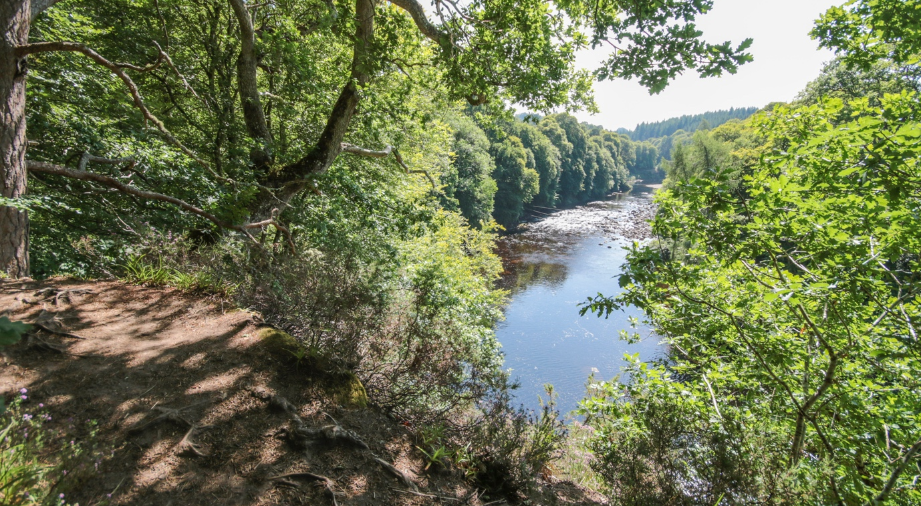

Creative Practitioner / River Animateur Application Pack

Key Details

Project: Findhorn Watershed Initiative

Title of post: Creative Practitioner / River Animateur

Accountable to: Findhorn Bay Arts

Hours: Part-time / 24 hours / anticipated average 3 days per week including evenings and weekends when required

Term: This is a fixed term contract for 6-months from October 2023 (exact date TBC) to 31st March 2024

Location: Forres, Moray

Salary: £28-32k pro-rata

Note: We are open to job-share/collaborative applications - where the applicants’ skills are complementary to each other in order to fulfil the role as per the spec

Introduction

About the Findhorn Watershed Initiative

The Findhorn Watershed Initiative (FWI) is a multi-generational vision to restore a mosaic of nature rich habitats, inspire a local culture of nature connection, and enable a thriving rural nature-based economy.

Catalysed by the urgent need to mitigate the impacts of climate breakdown on our river ecosystems and the wildlife that inhabits them, the Findhorn Watershed Initiative seeks to facilitate and accelerate a coordinated approach nature recovery.

The Findhorn Watershed Initiative has been instigated and is currently being led by trusted place-based conservation intermediary the Findhorn, Nairn, and Lossie Rivers Trust.

Based in the understanding that nature recovery is as much about skillsets, mindsets, and human relationships with nature as it is about the hands-on restoration work itself, the three integrated strands of FWI’s intended project outcomes are as follows:

Nature recovery

- Healthy, connected river woodlands, from the Monadhliath to the Moray Firth.
- A landscape supporting an abundance and diversity of life.
- Wild rivers shaped by natural processes increasing resilience to climate risks.
- A watershed fulfilling its carbon-storing potential, from peatlands to saltmarshes.

Connected communities

- Fostering a local culture of nature connection.
- Deepening a sense of pride and belonging within the watershed.
- Nurturing a spirit of stewardship and hope through caring for and protecting the places we love.

A regenerative rural economy

- More opportunities for high quality training, green jobs and nature-based enterprise.
- Income from natural capital investment benefiting all the watershed’s communities
- A river catchment accelerating Scotland’s just transition towards a wellbeing economy

The first phase of the FWI has a strong emphasis on working with landowners in the upper catchment to facilitate the creation and regeneration of riparian woodland along the upper River Findhorn and its tributaries, with the aim of shading the river and lowering water temperatures in order to make them more hospitable to the salmon and other wildlife.

More details about the Findhorn Watershed Initiative can be found here:
https://findhornwatershed.com/

About Findorn Nairn and Lossie Rivers Trust

The Findhorn, Nairn and Lossie Rivers Trust (FNLRT) promotes sustainable management of the Findhorn, Nairn, and Lossie river catchments and the wildlife that inhabits them through research, restoration and education. To achieve this, the Trust works closely with the District Salmon Fishery Boards for each river, and other relevant organisations. A charity and company limited by guarantee, the Trust relies on grants, donations and fundraising to implement its work.

The Findhorn Watershed Initiative was instigated in direct response to the Trust's 2021-26 Management Plan and builds on the organisation’s experience, expertise, and reputation as a trusted local environmental conservation intermediary, and the success of the ‘SISI’ invasive non-native species control project.

More details about the Findhorn, Nairn and Lossie Rivers Trust can be found here: https://www.fnlrt.org.uk/

About Findhorn Bay Arts

Findhorn Bay Arts (FBA) is an award-winning creative producer of cultural events and activities firmly rooted in the communities of Moray and our vision to “connect and celebrate Moray’s communities, places and people through exceptional and diverse creative experiences that challenge, inspire and delight”.

Now 11 years old, Findhorn Bay Arts (FBA) has grown from being synonymous with its biennial festival, into one that provides year-round opportunities that seek to bring cultural, economic and social benefit to the region, as well as those living and working in it.

Established in 2012, it is a non-profit organisation, a company limited by guarantee [SC413997], and a recognised Scottish charity [SC049867]. Our development has been significantly informed by a desire to increase recognition for Moray’s creative sector and for the positive role that arts and culture can make in so many parts of our lives.

Findhorn Bay Arts has been a driving contributor to the revitalisation of the region as a creative place, including establishing the biennial Findhorn Bay Festival, co-founding the Culture Cafe creative network, and contributing to the Moray Cultural Strategy: We Make Moray.

In recognition of the social, cultural, and economic impacts of its work, FBA has a strong reputation for working in partnership with a wide range of local, regional and national partners, attracting year-on-year support as well as winning numerous awards.

More details about Findhorn Bay Arts can be found here: https://findhornbayarts.com/

Funders

Between 2022-24 the pilot phase of the Findhorn Watershed Initiative is funded by the Scottish Government’s Just Transition Fund, NatureScot’s Nature Restoration Fund, and LNER’s Customer & Community Investment Fund. This role and programme of engagement is funded by the Scottish Government’s Just Transition Fund.

Project and Role Description

To support the community engagement strand of the Findhorn Watershed Initiative, the Findhorn, Nairn and Lossie Rivers Trust is partnering with fellow watershed-based creative production company Findhorn Bay Arts to deliver a programme of creative and cultural engagements in the lower River Findhorn catchment area.

To develop the programme, Findhorn Bay Arts are seeking to recruit a Creative Practitioner / River Animateur who can demonstrate a strong record of socially engaged, place-based practice with a background in research, engagement, curation and public commissions.

The role of Creative Practitioner / River Animateur is to develop a programme of social and ecologically engaged creative and cultural research and events which will help to animate the first phase of unfolding river and ecological restoration activities underway for local residents in the lower River Findhorn catchment.

The aim is to nurture watershed residents' senses of connection with, belonging to, and care for the river, its inhabitants, and the wider watershed.

By March 2024 we are seeking to bring together all the insights, stories, reflections, and voices engaged to date as part of the various threads of community engagement work underway along the full length of the River Findhorn, to begin to form the first iteration of a ‘River Findhorn Charter’.

Geographical Area:
The mid and lower catchment of the River Findhorn, its tributaries and catchment area; from Findhorn Bay and the coastal communities of the Moray Firth, up through the River Findhorn gorge and Finderne, to where the uplands begin at Drynachan Lodge.

Key themes:
- River Findhorn and its watershed, the wildlife that inhabits it, with an emphasis on the Atlantic Salmon and its awe-inspiring life cycle.
- Riverwoods/riparian woodland; the relationship between climate change, the survival of the iconic Atlantic Salmon, and the need for more trees and shade on our riverbanks.
- Other watershed ecosystems, and their biodiversity and carbon sequestrating supporting potential; from the saltmarsh, dunes and seagrass of Findhorn Bay, to meadows, wetlands, the dramatic mid-river gorge etc.
- The fundamental interdependency between ecological recovery and community and cultural empowerment.
- Meaningful relationships with the river, connection to community, rooted in place, watershed, sense of belonging.
- Village halls, reclaiming and enlivening common spaces, conviviality.
- Oral history, ‘carrying stream’, songs, stories, place names, maps, heritage paths, intangible cultural heritage related to the river.
- The three strands to FWI’s ‘Connected Communities’ vision: fostering a local culture of nature connection, deepening a sense of pride and belonging within the watershed, and nurturing a spirit of stewardship and hope through caring for and protecting the places we love.

Target stakeholders to engage with:

- Watershed residents and communities of place and/or interest:
  - Residents further downstream in the watershed catchment areas, including the following community council areas: East Nairnshire, Finderne, Dyke and Landward, Forres, Findhorn and Kinloss, to set the scene for the next phases of the Initiative to come.
  - Range of age groups: Children, Young people, Adults, Older people
  - Some other watershed community Organisations (such as Development Trusts, Village Halls, Charities etc).
  - Other river users (eg. Kayakers, Swimmers, Walkers, Anglers, where appropriate).

Responsibilities and Outputs:

- Delivery of a pilot programme of community engagement events which will help to animate the unfolding ecological restoration activities and increase a sense of nature connection and belonging to the watershed.
  - Possibly themed by river location, season, species, or habitat, and which enliven existing river and/or community infrastructure such as village halls.
  - Connect with FBA’s existing Combine to Create artist in residence whose residency focuses on the Findhorn Watershed. This residency will continue beyond the term of the animateur role.
- Gathering of memories, stories, insights, wishes for the future, ‘voices of the river’, ‘intangible cultural heritage’ etc, with a view to contributing towards creation of a first iteration of a River Findhorn Charter co-created between watershed stakeholders
  - These elements to be mapped geographically and fed into FWI’s GIS mapping system to feature in a ‘StoryMap’ (see example of this software in action here).
- Blogs/videos/recordings/podcasts/photos/maps/documentation learning resources of research and engagements undertaken in various forms which can be shared via FWI website and comms channels (and cross-shared with FBA channels too).
- Potential event(s) in coordination with FWI Upper Catchment Human Ecology Researchers in Residence towards the end of the project period to ‘translate’ and share findings up and down stream along the river; potentially a series of sharing events in watershed village halls.
- With support from office staff, overseeing booking process of these programmes, booking staff, liaising, and networking with key stakeholders including; schools, youth groups, care homes, community groups, landowners and the local education authority (LEA).
- With support from office staff ensuring all necessary administration tasks for the programmes are carried out including, for example, all correct documents are received e.g. booking forms, photo permissions etc.
- CRM data/mailing list of engaged and interested participants to keep informed and engage again in future.
- Quantitative and qualitative impact data from participants engaged (metrics to be defined with FBA & FWI team).
- Maintaining communication with FWI team and other community engagement project partners; attending meetings, coordinating plans with other project threads, etc.
- Final pilot programme report and recommendations ‘Handbook’ for longer term follow up watershed community cultural programme development and partnership (with a view towards informing future funding proposals e.g. Heritage Lottery Scotland, Scotland’s Year of Nature and the Natural World etc).

Intended Outcomes:

- Watershed residents experience increased nature connectedness supporting wellbeing and quality of life.
- Watershed residents feeling a deeper sense of pride and belonging within their watershed.
- Watershed residents fostering an increase spirit of stewardship and hope fostered through collaborating to restore the places we love.
- Empowered and invigorated watershed communities (of interest and/or place).
- Supported local economies.
- FWI/FNLRT team better understand the unique cultural context of the mid and lower Findhorn catchment and its communities and its relationship to the intended outcomes of the Initiative; their needs, wishes, concerns, suggestions.

Key Milestones / Timeline:

- Initiation, project background research and meetings with all core project partners (Oct 2023).
- Design engagement programme (Nov 2023).
- Delivery of engagement activities, community consultation and research (Nov 2023 to Feb 2024).
- First draft report (10 March 2024).
- Final report (31 March 2024).

Reporting to:

The Creative Practitioner / River Animateur will be based at the offices of Findhorn Bay Arts (Forres), line managed and work closely with the Creative Director of Findhorn Bay Arts in the development of this programme, and will be supported by the organisations Marketing and Communications Manager, Finance and Administration.

The Creative Practitioner / River Animateur will be required to participate in monthly FWI Partner meetings facilitated by the Findhorn Watershed Initiative Strategy Lead, and will also work in coordination and collaboration with the FNLRT and FWI teams, as necessary in relation to the wider project.

Skills and Experience

Essential:

- A professional qualification and / or a minimum of five years professional experience of working in the cultural, arts or heritage sector.
- A professional qualification and / or a minimum of five years professional experience of working in socially engaged / participatory arts-based practice and an understanding of creative place-making practices.
- Have a passion for nature and the natural world and understanding of conservation and wilderness restoration work whilst being open to learning and developing in the role.
- Excellent research, written communication and writing skills.
- Excellent administration, organisation, and time management skills combined with exemplary attention to detail and clarity of communication, with the confidence to take ownership of responsibilities and follow them through successfully.
- Good computer literacy with experience and enthusiasm in cloud-based software and IT systems including all Microsoft applications (Word, Excel, PowerPoint, Publisher) and Adobe PDF.
- Experience of managing budgets.
- Experience of partnership working and collaboration.
- Experience of initiating, organising and delivering public activities and events.
- Ability to collaborate and work effectively in a team.
- Proven initiative and high levels of self-motivation, as well as the ability to work unsupervised with experience of remote working, and the ability to work from home.
- Ability to work flexible hours and to travel to attend events and activities.
- Flexible working approach.
- PVG Disclosure Scotland Certificate.

Desirable:

- Knowledge of the communities and landscapes of the River Findhorn.
- Experience of fundraising.
- Experience of working with CRM software systems.
- Current UK Driving Licence and access to vehicle.
- First Aid certification (outdoors).

Findhorn Bay Arts is committed to equality and fairness for all. People will be engaged based on their ability and merits of their suitability for the job. FBA will not discriminate on grounds of age, disability, gender, gender reassignment, race, religion or belief, or sexual orientation. If you have any questions about our working environment, please get in touch.

How to Apply

Please send your CV and a covering letter, no more than 2 pages stating why this opportunity appeals to you, your experience in relation to the person specification outlining how you meet the requirements and what you think you bring to the role, as well as an outline of your proposed methodology. We would also like to receive up to 4 examples of your work.

If you are applying as a duo / job share please also outline how your collaboration will work and where each skill set compliments each other.

Please submit your application here.

We will only request references from the successful candidate(s).

The information you supply in your application, and by completing the equalities monitoring form, is kept securely and will remain confidential. We will not retain this or any other personal information beyond the duration of the application process except in using anonymised data for the purposes of monitoring and reporting.

Recruitment Schedule

17 July 2023 Applications open

16 Aug 2023 Deadline for applications (12noon)

21 Aug 2023 Applicants advised whether or not they have been selected for interview

25 Aug 2023 Interviews take place (online or in person)

30 Aug 2023 All interviewed applicants are notified of the outcome of their application

Sep/Oct 2023 Successful applicant in post and starts as soon as possible / agreeing exact start date with FBA

If you require further information before completing your application, please feel free to contact Kresanna Aigner, Creative Director / CEO, Findhorn Bay Arts, at director@findhornbayarts.com for an informal conversation about the role.

